CORE JAVA
STUDY METERIAL
By
Mr.K.VEERENDRANATH _{M.Tech}
_{Ph: 99499 39869, 9014424466}
veerendranath.tech@gmail.com

Java is a programming language and a platform.
Java is a high level, robust, object-oriented and secure programming language.
Platform:
Any hardware or software environment in which a program runs, is known as a platform. Since Java has a runtime environment (JRE) and API, it is called a platform.
Java Programming is a general-purpose object-oriented programming language, designed for the development of software for consumer electronic devices such as TVs, VCRs, toasters, etc.
Java Programming Language is a platform neutral language, which means it is not tied to any particular hardware or operating system. It guarantees users to ‘write once, run anywhere’. Java language is supported by almost every operating system such as Sun Solaris, RedHat, Windows etc.
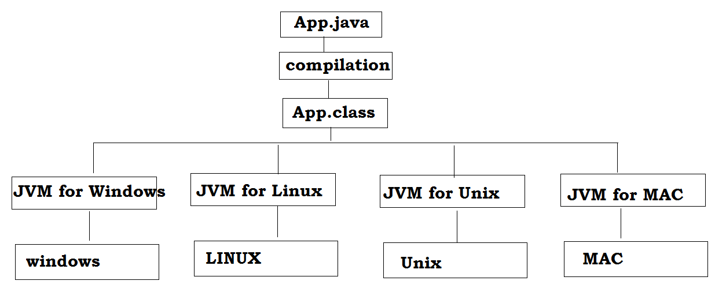
Note:
It is a combination of features of C and C++ with some essential additional concepts. It has obtained its format from C, and OOP features from C++.
Java is well suited for both standalone and web application development and is designed to provide solutions to most of the problems faced by users of the internet era.

COMPUTER-BASICS
Why languages, like C&C++, are not opted for a network and why Java is a language suited for a network, especially Internet.
Interconnection of computers is called network. A network may contain two or more computers connected with or without a cable. For example, you can connect a computer in Delhi to one placed in Hyderabad with the help of a satellite and data can be sent or received via satellite in the form of electromagnetic waves. So, a network may or may not have a cable.
The primary purpose of a network is resource sharing, which means a computer can share its resources, like data, memory, software, hardware, CPU, etc. with other computers on the network.
In the network, one computer may ask the other computer for some service. The computer, which requests for some service is called client and the other computer, which provides that service to the client· is called' server. A network can have several clients and servers and such network architecture is also called client/server architecture.
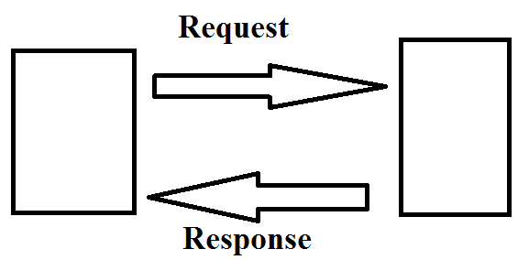
Note: Client sends request for service and Server sends response to client.

What is the advantage of a network?
The main advantage of a network is that it makes resource sharing possible among the connected Systems, thus helping in better utilization 'of resources.
How we can connect one computer to another?
Hardware: Computer systems, Network Interface Cards (NIC), cables, modems, hubs, satellites, etc. ,.
Software: Any software, which supports networking features, like UNIX, Linux, Windows -NT, etc. so that data can be sent or received.
Protocol: Protocol could be defined as a standard procedure for regulating data transmission between computers. It specifies a way to identify the destination and source computers and establish a connection 'between them to receive or send data. For example, TCP/IP or UDP protocols help to divide data into small packets of several bytes, insert the packets into frames, and then send those frames to the destination computer over the network. Protocol is the underlying feature of the software used on the network.
A network of computers within an organization is called Intranet. An external network connecting an organization's network with that of another organization is called Extranet. In other words, we can take Extranet as a network outside an organization connecting it to other organizations' network. Similarly, an organization may use the services of a third party private network to communicate with outside networks. This third party private network is called VAN (Value Added Network).
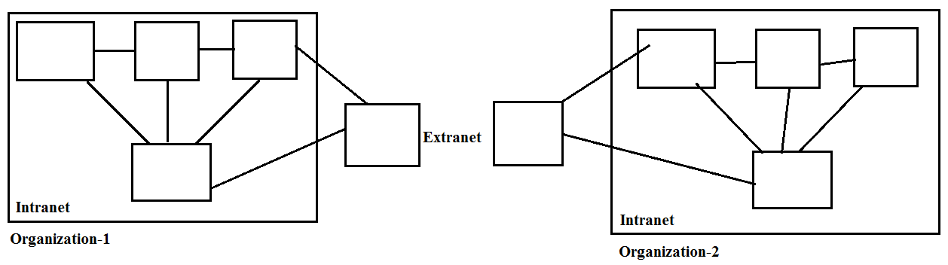

Which is the most widely used protocol on Internet?
Hypertext transfer protocol (http) is the most widely used protocol on Internet. The text on Internet is sent or received from one machine to another using this protocol only.
Software Development for internet:
Software:
As per the industrial standard a “digitalized (GUI) automated system” is called software.
Digitalized: When the software where is providing graphically user interface then it is called digitalized.
Automated system: Without human interaction if the process is completed then it called automated system.
Software is nothing but a collection of programs. A program is a set of instructions which is designed for particular task.
A number of programs combining together like a single unit it is called software tool of software component.
Software are classified into two types:
1. System software
2. Application software.
1. System software:
The software design for general purpose & does not having any limitations it is called system software.
Note: System software manages the computer resources. It provides the interface between the hardware and the users but does nothing to directly serve the user’s needs.

System software are classified into 3-types:
1. Operating systems: Dos, windows, Linux, UNIX…
2. Translators: Compilers, interpreters, assemblers…
3. Packages: linkers, loaders, editors…
2. Application software:
This software is designed for specific task only it is application software.
Note: Application software is directly responsible for helping users solve their problems.
Ex: application software are classified into 2-types:
1. Application packages: MS office, Oracle…
2. Specific purpose software: Tally..
- Ms Office is a Microsoft product which maintains the information in document format.
- Oracle is a database which maintains the information in document format.
- By using Tally we can maintain the information of accounts.

Computer:
A computer is an electronic device which accepts instructions from user and according to user sended instruction it produces result.
Computer is an electronic device which operates under the control of instructions stored in its own memory. A computer can take data from the user through input devices (Input), process the user given data (Processing), produces the result to the user through output devices (Output)and stores data (Information) for future use.
Note: Computer knows only one language i.e binary language.
How does Computer works?
When a user wants to communicate with the computer, the user interacts with an application.
The application interacts with the operating system, and the operating system makes hardware components to work according to the user given instructions.
The hardware components sends the result back to the operating system, then the operating system forwards the same to the application and the application shows the result to the user.
By using input devices, the user interacts with the application and the application uses output devices to show the result.
All input and output devices work according to the instructions given by the operating system.
The working process of a computer is shown in the following figure...

Computer Languages
What is Computer Language?
Generally, we use languages like english, hindi, telugu etc., to make communication between two persons. That means, when we want to make communication between two persons we need a language through which persons can express their feelings.
As a programmer when we required interacting with a computer we need a communication channel called programming language.
Similarly, when we want to make communication between user and computer or between two or more computers we need a language through which user can give information to computer and vice-versa.
When user wants to give any instruction to the computer the user needs a specific language and that language is known as computer language.
User interacts with the computer using programs and that programs are created using computer programming languages like C, C++, Java etc.,
A programming language is a special kind of instructions which is used to communicate with computer.
As a programmer if we knows the programming language then it is not possible to interact with computer because computer can understand binary code only.
In the above case, recommended to use translator. As a programmer if the instruction came from the programming language, translator will converts programming language code into binary format and according to even binary instructions we will get application software.

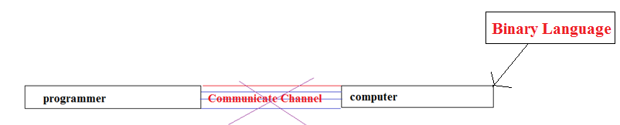
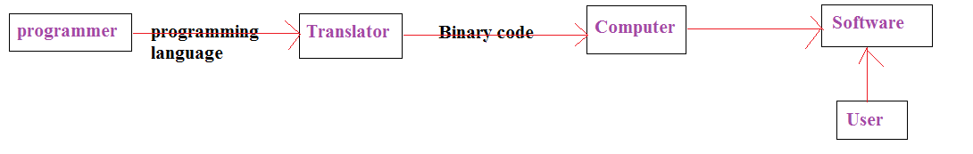
Note: Computer languages are the languages through which user can communicate with the computer by writing program instructions.
Translators:
A translator is system software which can convert programming language code into binary format.
Translators are classified into 3-types:
- Compiler
- Interpreter.
- Assembler.
1. Compiler:
It is system software which can converts programming language code into binary language format in a single step except those lines are having error.
2. Interpreter:
It is system software which converts programming language code into binary format step by step i.e line by line combination takes place.
Note: when in it error occurs it stops the compilation process.
3. Assembler:
By using assembler we can convert assembly language instructions into binary formats.
Note: As per the performance wise recommended to use compiler and as per the development wise recommended to use an interpreter.
Programming language
A programming language is a special kind of instructions which is used to communicate with computer.
Every computer programming language contains a set of predefined words and a set of rules (syntax) that are used to create instructions of a program.
Computer Languages Classification:
Over the years, computer languages have been evolved from Low Level to High Level Languages. In the earliest days of computers, only Binary Language was used to write programs.
The computer languages are classified as follows...
Programming language is classified into 2-types:
1. Low level programming language.
2. Middle Level Programming language.
3. High level programming language.
1. Low level programming language:
Low Level language is the only language which can be understood by the computer. Binary Language is an example of low level language. Low level language is also known as Machine Language.
The binary language contains only two symbols 1 & 0. All the instructions of binary language are written in the form of binary numbers 1's & 0's.
A computer can directly understand the binary language. Machine language is also known as Machine Code.
As the CPU directly understands the binary language instructions, it does not requires any translater. CPU directly starts executing the binary language instructions, and takes very less time to execute the instructions
Note: Low level language is specific to one machine i.e. machine dependent. It is machine dependent, fast to run. But it is not easy to understand.
Advantages:
- A computer can easily understand the low level language.
- Low level language instructions are executed directly without any translation.
- Low level language instructions require very less time for thier execution.
Disadvantages:
- Low level language instructions are very difficult to use and understand.
- Low level language instructions are machine dependent, that means a program written for a particular machine does not executes on other machine.
- In low level language, there is more chance for errors and it is very difficult to find errors, debug and modify.

Middle Level Language (Assembly Language):
Middle level language is a computer language in which the instructions are created using symbols such as letters, digits and special characters. Assembly language is an example of middle level language. In assembly language, we use predefined words called mnemonics.
Binary code instructions in low level language are replaced with mnemonics and operands in middle level language. But computer cannot understand mnemonics, so we use a translator called Assembler to translate mnemonics into binary language. Assembler is a translator which takes assembly code as input and produces machine code as output. That means, computer cannot understand middle level language, so it needs to be translated into low level language to make it understandable by the computer. Assembler is used to translate middle level language to low level language.
Advantages:
- Writing instructions in middle level language is easier than writing instructions in low level language.
- Middle level language is more readable compared to low level language.
- Easy to understand, find errors and modify.
Disadvantages:
- Middle level language is specific to a particular machine architecture that means it is machine dependent.
- Middle level language needs to be translated into low level language.
- Middle level language executes slower compared to low level language.
High level programming language:
High level language is a computer language which can be understood by the users. programming language is syntactically similar to English and easy to understand it is called high level programming language.
Every high level language has a set of predefined words known as Keywords and a set of rules known as Syntax to create instructions. High level language is easier to understand for the users but the computer cannot understand it. High level language needs to be converted into low level language to make it understandable by the computer. We use Compiler or interpretor to convert high level language to low level language.
By using high level programming language we are developing user interface applications.
Ex: C, C++, Vc++, java, C#, Swift, Objective C, D-language, COBOL, FORTRAN, BASIC are the examples of high level languages. All these programming languages use human understandable language like english to write program instructions. These instructions are converted to low level language by the compiler so that it can be understood by the computer.
Note: High Level language is not specific to one machine i.e. machine independent. It is easy to understand.
Advantages:
- Writing instructions in high level language is more easier.
- High level language is more readable and understandable.
- The programs created using high level language runs on different machines with little change or no change.
- Easy to understand, create programs, find errors and modify.
Disadvantages:
- High level language needs to be translated to low level language.
- High level language executes slower compared to middle and low level languages.

Understanding Computer Languages:
The follwing figure provides few key points related to the computer languages.
From the above figure, we can observe the following key points...
- The programming languages like C, C++, Java etc., are written in High level language which is more comfortable for the developers.
- High level language is more closer to the users.
- Low level language is more closer to the computer. Computer hardware can understand only the low level language (Machine Language).
- The program written in high level language needs to be converted to low level language to make communication between the user and the computer.
- Middle level language is not closer to both user and computer. We can consider it as a combination of both high level language and low level language.

Program Development Life Cycle(SDLC)
Waterfall approach was first SDLC Model to be used widely in Software Engineering to ensure success of the project. In "The Waterfall" approach, the whole process of software development is divided into separate phases. In Waterfall model, typically, the outcome of one phase acts as the input for the next phase sequentially.
Following is a diagrammatic representation of different phases of waterfall model.
The sequential phases in Waterfall model are:
Requirement Gathering and analysis: All possible requirements of the system to be developed are captured in this phase and documented in a requirement specification doc.
System Design: The requirement specifications from first phase are studied in this phase and system design is prepared. System Design helps in specifying hardware and system requirements and also helps in defining overall system architecture.
Implementation: With inputs from system design, the system is first developed in small programs called units, which are integrated in the next phase. Each unit is developed and tested for its functionality which is referred to as Unit Testing.
Integration and Testing: All the units developed in the implementation phase are integrated into a system after testing of each unit. Post integration the entire system is tested for any faults and failures.
Deployment of system: Once the functional and non functional testing is done, the product is deployed in the customer environment or released into the market.
Maintenance: There are some issues which come up in the client environment. To fix those issues patches are released. Also to enhance the product some better versions are released. Maintenance is done to deliver these changes in the customer environment.

2. EVOLUTION OF JAVA
The development of each programming language is based on a fact:
There is a need to solve a problem that was not resolved by previous programming languages.
Early programmers had to choose different programming languages, usually for various tasks, such as a specific language for a type of field.
A certain language was sufficient to solve the problems of its field but was not able to solve the problems of other fields.
For example, Fortran could have been used to write efficient programs for scientific problems, but it was not good for system code.
Similarly, Basic C was easy to understand but was not robust to write big programs; While the assembly language was powerful for writing efficient programs, but it was not easy to remember and execution.
Programming languages such as Cobol, Fortran do not have structural principles. They use the Goto statement to control the flow of the program. Therefore, programs using this type of code are made up of many jumps and conditional statements that make it difficult to understand.
Therefore, C was invented in 1970, to replace the assembly language and to create a structured, effective and high-level language. The development of C was the result of the development process started with BCPL by Dennis Ritchie. BCPL is an old language developed by Martin Richard. Ken Thompson developed a language called B, which was influenced by BCPL.
C is a processor-oriented programming language; it is easy to execute and understand. C became quite famous at that time because it was reliable, simple and easy to use.
Though C was quite efficient and successful programming language, the complexity of the program was seeking more efficient language to solve problems. When we write a program in C, it has a limit, such as a maximum of 25000 lines of code, beyond which it cannot handle the complexity. But writing and managing large programs was a demand at that time. So a new concept came.
C++ came with object-oriented programming features. C++ is the extension of C language which has been used extensively. It is a powerful modern language that includes the power and simplicity of C and the characteristics of OOP. C++ provides more functional software benefits than C.
C ++ with OOP became quite famous but then a new problem arose, to control the software on different machines, a separate compiler is required for that CPU. But building a C++ compiler was quite expensive. Therefore, an efficient and easy solution was needed, and this requirement became the reason for the creation of Java, which is a portable and platform-independent language.

Difference between C/C++ and Java:
1. C and C++ are the static programming language but java is the dynamic programming language?
If a program allows static memory allocation then that programming language is called as static programming language. That means memory allocation done at compile time.
Ex: C and C++
In C and C++ programming languages allocating memory for primitive data types at time of compile time.
If program allows dynamic memory allocation then that programming language is called as dynamic programming language. That means for primitive data type allocating memory at runtime time.
Ex: Java
In java programming language memory allocated for primitive data types at time of runtime and object is created at time of runtime.
2. Pre-processor is required in C- programming language but not required in Java programming language?
App.c:
#include<stdio.h>
#include<conio.h>
void main(){
printf (“hello”)
}
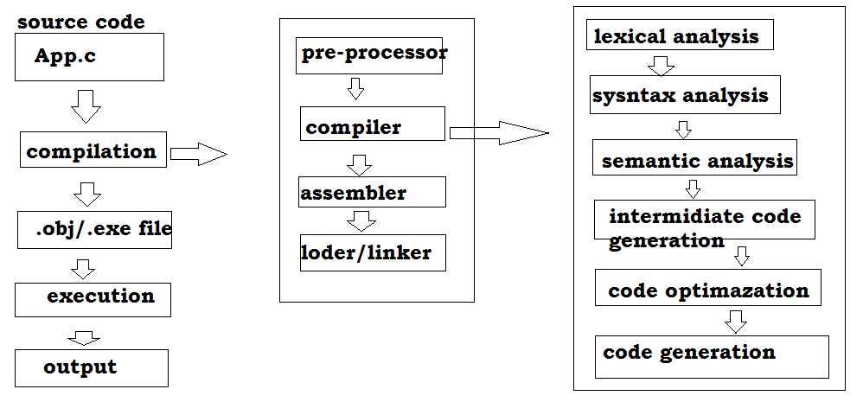
In c-programming language pre-defined libraries provided in form of header files.So in C /C++ we require #include statements
Ex:
#include<stdio.h>
#include<conio.h>
In C programming language pre-processor requires the #include statements that’s why pre-processors are required in c/C++.
In java:
import java.lang.*;
class App{
public static void main(String[] args){
System.out.println(“Hello”);
}
}
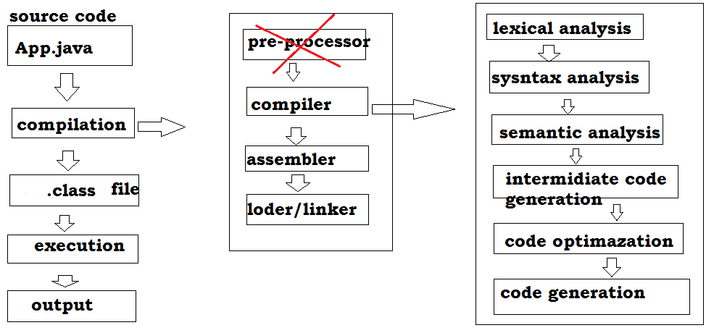In java programming completely pre-defined libraries are provided in the form of packages . in java we need to include packages into our application instead of #include statements.
Ex:
Java.lang.io.*;
Java.lang.*;
If compile our java application java compiler will recognize the import statements but not #include(not pre-processor) statements due to this in C/C++ pre-processor is required but not required in java.
3. Destructors are required in C++ but not required in Java.
In every object oriented programming language it is convention to create an object to store the data in the form of objects and destroy the object after usage.
Generally in object oriented programming languages we can create objects by using constructors and we can destroy the object by using the destructors.
In C++, developers are using constructors to create objects and using the destructors for destroys the objects.
In java, developers will take responsibility only for creating objects by using constructors they are not taking responsibility for destroy the objects why because in java in built Garbage collector is available which automatically destroy the objects.
In java due to availability of Garbage collector it is not required to destroy the object explicitly by the developers.
4. Java is platform independent language but C and C++ platform dependent language:
5. Pointers are available in C and C++ but In java Pointers are not available:
- Pointers are variable which used store address (location) of variable directly.
- Pointers are recognized or initialized at time of compilation only.
- Pointers are not available in java because pointers are required memory at time of compilation which is nothing but static memory allocation but following Java is dynamic memory allocation.
- Pointers are supporting for platform dependent programming languages but java is platform independent.
- Pointers are reducing the security.
- Pointers are make confusion for programmers.
7. call by value and call by reference possible by C and C++ but Java will support only call by value.
Getting Started with Java:
Communicating with a computer involves speaking the language the computer understands, which immediately rules out English as the language of communication with computer. However, there is a close analogy between learning English language and learning Java language. The classical method of learning English is to first learn the alphabets used in the language, then learn to combine these alphabets to form words, which in turn are combined to form sentences and sentences are combined to form paragraphs. Learning java is similar and easier. Instead of straight-away learning how to write programs, we must first know what alphabets, numbers and special symbols are used in java, then how using them constants, variables and keywords are constructed, and finally how are these combined to form an instruction. A group of instructions would be combined later on to form a program.
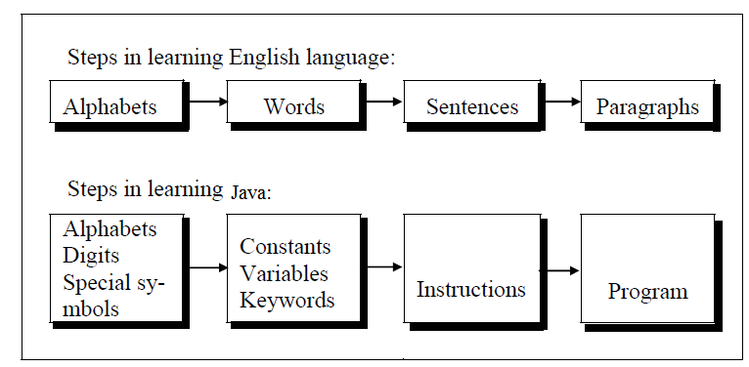

INTRODUCTION TO JAVA
Before starting to learn Java, let us plunge into its history and see how the language originated. In 1990, Sun Microsystems Inc. (US) was conceived a project to develop software for consumer electronic devices that could be controlled by a remote. This project was called Stealth Project but later its name was changed to Green Project.
In January of 1991, Bill Joy, James Gosling, Mike Sheradin, Patrick Naughton, and several others met in Aspen, Colorado to discuss this' project. Mike Sheradin was to focus on business development; Patrick Naughton was to begin work on the graphics system; and James Gosling was to identify the proper programming language for the project. Gosling thought C and C++ could be used to develop the project. But the problem he faced with them is that they were system dependent 'languages and hence could not be used on various processors, which the electronic devices might use. So he started developing a new language, which was completely system independent. This language was initially called Oak. Since this name was registered by some other company, later it was changed to Java.
Why the name Java? James Gosling and his team members were consuming a lot of tea while developing this language. They felt that they were able to develop a better language because of the good quality tea they had consumed. So the tea also had its own role in developing this language and hence, they fixed the name for the language as Java. Thus, the symbol for Java is tea cup and saucer.

FEATURES OF JAVA
Apart from being a system independent language, there are other reasons too for the immense popularity of this language. Let us have a look at some of its features.
The features of Java are also known as java buzzwords.
- Simple
- Object-Oriented
- Portable
- Platform independent
- Secured
- Robust
- Architecture neutral
- Dynamic
- Interpreted
- High Performance
- Multithreaded
- Distributed
1. Simple (Java is Simple Programming Language):
Java is a simple programming language. Rather than saying that this is the feature of
Java, we can say that this is the design, aim of Java. When 'Java is developed, they wanted it to be simple because it has to work on electronic devices, where less memory is available. Now the question is how Java is made simple? First of all, the difficult concepts of C and C++ have been omitted in Java. For example, the concept of pointers-which is very difficult for both learners and programmers-has been completely eliminated from Java. Next, 'JavaSoft (the team who developed Java is called with this name) people maintained the same syntax of C and C++ in Java, so that a programmer who knows C or C++ will find Java already familiar.
- No support for pointers.
- No "goto" keyword. The minus point of "goto" is that you lose the command on control flow of the code and thereby debugging becomes a nightmare.
- No support for unsigned data types.
- No operator overloading.
- No preprocessor directives (# define).
- No multiple inheritances.
- No garbage values for unassigned data types.
- No explicit memory management by the developer. Memory management is taken care implicitly.
- No structures, no templates and no unions.
- No need to remove unreferenced objects because there is Automatic Garbage Collection in java.
Why pointers are eliminated from Java?
- Pointers lead to confusion for a programmer.
- Pointers may crash a program easily, for example, when we add two pointers, the program, crashes immediately. The same thing could also happen when we forgot to free the memory allotted to a variable and re-allot it to some other variable.
- Pointers break security. Using pointers, harmful programs like Virus and other hacking programs can be developed. Because of the above reasons, pointers have been eliminated from Java.
How can you call the garbage collector?
Garbage collector is automatically invoked when the program is being run. It can be also called by calling gc() method of Runtime class or System class in Java.
Which algorithm is used by garbage collector to remove the unused variables or objects from memory?
Garbage collector uses many algorithms but the most commonly used algorithm is mark and sweep.
2. Object-Oriented
Java is Object-oriented programming language. Everything in Java is an object. Object-oriented means we organize our software as a combination of different types of objects that incorporates both data and behavior.
Object-oriented programming (OOPs) is a methodology that simplifies software development and maintenance by providing some rules.
What is an object? An object is anything that really exists in the world and can be distinguished from others. Everything that we see physically will come into this definition, for example every human being, a book, a tree, and so on.
Every object has properties and exhibits certain behavior. An example of a dog. It got properties like name, height; color, age, etc. These properties are represented by variables. Now, the- object dog will have some actions like running, barking, eating, etc. These actions are represented by various methods (functions) in our programming. In programming, various tasks are done by methods only. So, we can conclude that objects contain variables and methods.
A group of objects exhibiting same behavior (properties + actions) will come under the same group called a class. A class represents a group name given to several objects. For example, take the clogs: Pinky, Nancy, Tom, and Subbu. All these four dogs exhibit same behavior and hence belong to the same group, called dog. So dog is the class name, which contains four objects.In other words, we could define a class as a model or a blueprint for creating the objects. We write the characteristics of the objects in the class dog. This means, a class can be used as a model in creation of objects. So just like objects, a class also contains properties and actions, i.e. variables and methods.
We can use a class as a model for creating objects. To write a class, we· can write all the characteristics of objects which should follow the class. These characteristics will guide us to create the objects. A class and its objects are almost the same with the difference that a class does not exist physically, while an object does.
What is the difference between a function and method?
- A method is a function that is written in a class. We do not have functions in Java; instead we have methods. This means whenever a function is written in Java, it should be written inside the class only.
- But if we take C++, we can write the functions inside as well as outside the class. So in C++, they are called member functions and not methods.
Note:
- Java is a purely object oriented programming language, in order to write a program in Java, we need atleast a Class or an object. This is the reason why in every Java program we write atleast one class.
- C++ is not a purely object-oriented language, since it is possible to write programs in C++ without using a class or an object
Basic concepts of OOPs are:
- Object
- Class
- Inheritance
- Polymorphism
- Abstraction
- Encapsulation
3. Platform Independent:
Platform dependent:
If any programming language allows its applications to compile and execution on same platform (Operating System) then that programming language is said be a platform dependent programming language.
Ex: C and C++
If we compile C application on windows operating system then C compile will generate the “.obj” file or “.exe file” as per windows operating system representation.
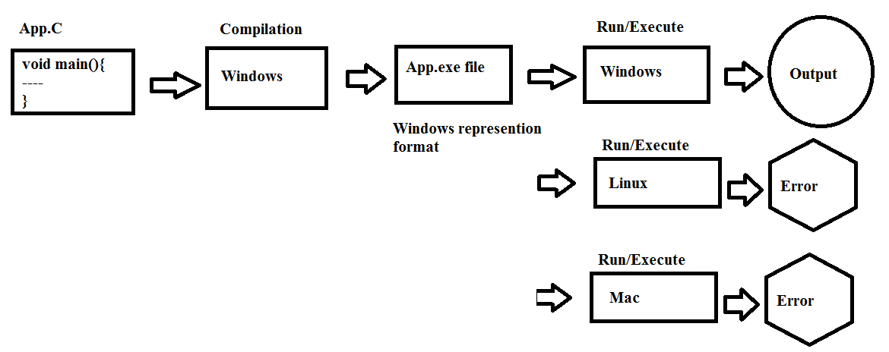
If we want to run or execute this windows represented file we should have same operating system at run time this nature is treated as platform dependent. Otherwise we will get error.
So that C programming language is platform dependent.
Platform Independent:
If any programming language allows its applications to compile on one platform (Operating System) and allows run or execute on any platform that programming language is said be a platform independent programming language.
Ex: Java, Python.
If we compile java program on windows then java compiler will generate “.class file” which contains byte code and which is neutral for every operating system. Byte code is note directly executable code which is intermediate code.
Java is platform independent because it is different from other languages like C, C++ etc. which are compiled into platform specific machines while Java is a write once, run anywhere language (WORA)
Note:
Java's byte code is not machine dependent. It can be run on any machine with any processor and any operating system.
Note: java is platform independence due to availability of JVM. Java is also called as WORA (Write Once Run Anywhere).
But JVM is platform dependency
Java's Magic of Byte code:
Byte code is a new term to the programming world introduced by Java. The compilation product of Java source file is a .class file consisting of byte code. This byte code makes Java platform-independent where as the binary code of C/C++ makes C/C++ platform-dependent.
The byte code is not an ultimate format that is readily understood by the microprocessor. It must be converted into binary code format that can be processed by the microprocessor directly. This conversion is taken care by the JVM. The format conversion takes some time and thereby Java executes slower. In case of C/C++, they contain binary code directly.
Note: The slow nature is overcome to some extent with the introduction of JIT (Just-In-Time) compiler.
Note: A compiler job is to compile the source code into an executable file. An executable file, as the name indicates, gives output when executed.
4. Secured:
Java is best known for its security. With Java, we can develop virus-free systems. Java is secured because:
- No explicit pointer.
- Java Programs run inside virtual machine sandbox.
Note: Security problems like eavesdropping, tampering, impersonation, and virus threats can be eliminated or minimized by using Java on Internet
- Class loader: Class loader in Java is a part of the Java Runtime Environment (JRE) which is used to dynamically load Java classes into the Java Virtual Machine. It adds security by separating the package for the classes of the local file system from those that are imported from network sources.

Which part of JVM will allocate the memory for a Java program?
Class loader subsystem of JVM will allocate the necessary memory needed by the Java program.
- Byte code Verifier: It checks the code fragments for illegal code that can violate access right to objects.
- Security Manager: It determines what resources a class can access such as reading and writing to the local disk.
These securities are provided by java language. Some security can also be provided by application developer through SSL, JAAS, and Cryptography etc.
5. Robust:
Robust simply means strong. Java is robust because:
- It uses strong memory management.
- There are lack of pointers that avoids security problem.
- There is automatic garbage collection in java.(no need to delete unused object by the programmer )
- There is exception handling and type checking mechanism in java. which takes care of user's mistakes at runtime.
- Java includes a strong type checking for objects and data types both at compile time and runtime.
- Variables must be assigned before they are used.
- Array size should not be given in initialization.
- All these points make java robust.
6. Architecture-neutral:
Java is architecture neutral because there are no implementation dependent features. The binary code conversion is effected by the JVM. The bytecode is OS architecture neutral. Any OS can execute the byte code without bothering its architecture.e.g. size of primitive types is fixed.
In C programming, int data type occupies 2 bytes of memory for 32-bit architecture and 4 bytes of memory for 64-bit architecture. But in java, it occupies 4 bytes of memory for both 32 and 64 bit architectures.
7. Portable
Portability for Java comes from its byte code. A Java .class file, obtained from the compilation on one platform can be ported or carried, for execution, to a different platform. The necessity is to have a compatible JVM (specific to the platform). JDKs are different for different platforms.
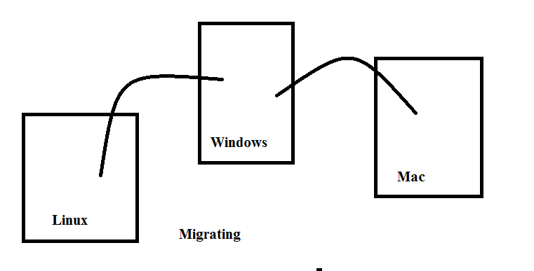
8. High-performance
Java is faster than traditional interpretation since bytecode is "close" to native code still somewhat slower than a compiled language (e.g., C++). Java is an interpreted language, so it is also a reason that why it is slower than compiled language C, C++.
The-problem with interpreter inside the JVM is that it is slow. Because of this, Java programs used to run slow. To overcome this problem, along with the interpreter, JavaSoft people have introduced JIT (Just In Time) compiler, which enhances the speed of' execution. So now in JVM, both interpreter and JIT compiler work together to run the program.

9. Distributed:
Information is distributed on various computers on a network. Using Java, we can write programs, which capture information and distribute it to the clients. This is possible because Java can handle the protocols like TCP/IP and UDP.
10. Multi-threaded:
A thread is like a separate program, executing concurrently. We can write Java programs that deal with many tasks at once by defining multiple threads. The main advantage of multi-threading is that it doesn't occupy memory for each thread. It shares a common memory area. Threads are important for multi-media, Web applications etc.
11. Dynamic:
Before the development of Java, only static text used to be displayed-in the browser.But when James Gosling demonstrated an animated atomic molecule where the rays are moving and stretching, the views were dumbstruck. This animation was done using an applet program, which are the dynamically interacting programs on Internet.
12. Interpreted: Java programs are compiled to generate the byte code. This byte code can be downloaded and interpreted by the interpreter in JVM. If we take any other language, only an interpreter or a compiler is used for execute the programs. But in we use both compiler and interpreter for the execution.
13. Scalability:
Java platform can be implemented on a wide range of computers with varying levels of resources-from embedded devices to mainframe computers. This is possible because java is compact and platform independent.

C++ vs Java:
Comparison Index | C++ | Java
Platform-independent | C++ is platform-dependent. | Java is platform-independent.
Mainly used for | C++ is mainly used for system programming. | Java is mainly used for application programming. It is widely used in window, web-based, enterprise and mobile applications.
Goto | C++ supports goto statement. | Java doesn't support goto statement.
Multiple inheritance | C++ supports multiple inheritance. | Java doesn't support multiple inheritance through class. It can be achieved by interfaces in java.
Operator Overloading | C++ supports operator overloading. | Java doesn't support operator overloading.
Pointers | C++ supports pointers. You can write pointer program in C++. | Java supports pointer internally. But you can't write the pointer program in java. It means java has restricted pointer support in java.
Compiler and Interpreter | C++ uses compiler only. | Java uses compiler and interpreter both.
Call by Value and Call by reference | C++ supports both call by value and call by reference. | Java supports call by value only. There is no call by reference in java.
Structure and Union | C++ supports structures and unions. | Java doesn't support structures and unions.
Thread Support | C++ doesn't have built-in support for threads. It relies on third-party libraries for thread support. | Java has built-in thread support.
Documentation comment | C++ doesn't support documentation comment. | Java supports documentation comment (/** ... */) to create documentation for java source code.
Virtual Keyword | C++ supports virtual keyword so that we can decide whether or not override a function. | Java has no virtual keyword. We can override all non-static methods by default. In other words, non-static methods are virtual by default.
unsigned right shift >>> | C++ doesn't support >>> operator. | Java supports unsigned right shift >>> operator that fills zero at the top for the negative numbers. For positive numbers, it works same like >> operator.
Inheritance Tree | C++ creates a new inheritance tree always. | Java uses single inheritance tree always because all classes are the child of Object class in java. Object class is the root of inheritance tree in java.

STRUCTURE OF THE JAVA PROGRAMMING
When we are writing any program in any language we need to follow a standard structure for writing the program which is recommended by the language experts. A java program may contain many classes of which only one class will have a main method. Class will contain data members and methods that operate on the data members of the class. To write a Java program, we first need to define classes and then put them together. Generally a standard java program consists of following blocks as shown in below figure.
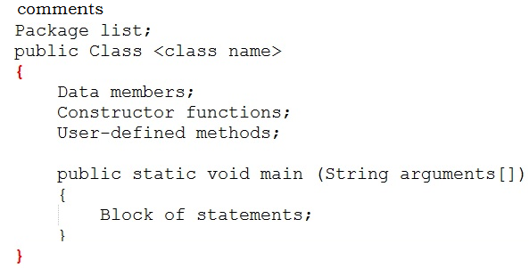
Explanation:
Java Comments:
Whenever we want to write a program, we should first think about writing comments. Comments are described about the features of a program. This means that whatever we write in a program should be described using comments.
Note: The java comments are statements that are not executed by the compiler and interpreter. The comments can be used to provide information or explanation about the variable, method, class or any statement. It can also be used to hide program code for specific time.
Why we should write comments?
When we write comments, we can understand what the program is doing as well as it helps others to easily follow our code.
This means readability and understandability of a program will be more. If a program is understandable, then only can it be usable in software. If other members of the software development team cannot understand our program, then they may not be able to use it in project and will reject it.
Types of Java Comments
There are 3 types of comments in java.
- Single Line Comment
- Multi Line Comment
- Documentation Comment
Single Line Comment: These comments are for marking a single line as a comment. These comments starts with double slash (//) and after this, whatever is written till the end of the line is taken as a comment.
Ex: //this is my single line comment
Multi Line Comment: These comments are used for representing several lines as comments. These comments start with (/*) and with (*/) in between /* and*/ whatever is written is treated as a comment.
Ex:
/* this is multi line comment.
This is line-1
This is line-2
This is line-3 */
Documentation Comment: These comments are start with /** and end with */. These comments are used to provide description for every feature in java program. This description proves helpful in the creation of a .html file called API (Application Programming Interface) document.
Note: he documentation comment is used to create documentation API. To create documentation API, you need to use javadoc tool.

/** description about class */
Class Code
---
/** description about method */
method Code
Package:
Package is a collection of classes, interfaces and sub packages. In a java program if we are using any pre-defined classes and interfaces then it is the responsibility of the java programmer to import that particular package containing such specific classes and interface. In java by default java.lang.* package is imported by every program.
Class:
Class is a keyword used for developing user defined data types. Every java program must starts with a prototype of class. The class has been declared public, means all classes can access the class from all packages. Generally, however, we will declare classes in java without specifying a modifier.
Class name:
Class name is the name given to that class. Every class name is treated as one kind of user defined data type.
Data Members:
Data Members represents either instance members or static members.
Constructor:
Constructor function is called when an object of the class is created. It is a block of code that initializes the newly created object. The constructor simply has the same name as the name of the class name. A constructor does not have a return type. A constructor is called automatically when a new instance of an object is created. In the following code, the constructor bird() prints a message.
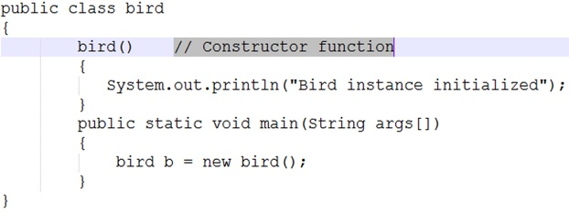
When we create the object of the bird class as shown above:
bird b = new bird();
The new keyword here creates the object of class bird and invokes the constructor to initialize this newly created object.
Constructor and method are different because the constructor is used to initialize the object of a class while the method is used to perform a task by implementing java code. Constructors cannot be declared as abstract, final, static and synchronised while methods can be declared. Constructors do not have return types while methods do.
User-defined methods:
User-defined methods represent either instance (or) static and they will be selected depends on the class name and these methods are used for performing the operations either once (or) repeatedly. All the user-defined methods of a class contain logic for a specific problem. These methods are known as Business logic methods.

Starting a java Program:
Requirement for Hello Java Example
For executing any java program, you need to
- install the JDK if you don't have installed it, download the JDK and install it.
- Set path of the jdk/bin directory.
- create the java program
- compile and run the java program

Creating First java example
import java.lang.System;
import java.lang.String;
public class FirstApp {
public static void main(String[] args) {
System.out.println("welcome to java language");
}
}
Save this file as FirstApp.java
To compile: | javac FirstApp.java
To execute: | java FirstApp
Parameters used in first java program
What is the meaning of class, public, static, void, main, String[], System.out.println().
- class keyword is used to declare a class in java.
How to create class?
After importing the classes in to the program, the next step is to write class. Java is a purely object oriented programming language, we cannot write a java program without having at least one class or object.
We can write class by using class keyword then we write the class name.
Class FirstApp{
//Statements
}
Note: class contain variables and methods
- public keyword is an access modifier which represents visibility, it means it is visible to all.
- static is a keyword, if we declare any method as static, it is known as static method. The core advantage of static method is that there is no need to create object to invoke the static method. The main method is executed by the JVM, so it doesn't require to create object to invoke the main method. So it saves memory.
- void is the return type of the method, it means it doesn't return any value.
- main represents the starting point of the program.
If main() method is not written in a java program JVM will not execute it. main() is the starting point for JVM to start execution of a java program.
- String[] args is used for command line argument.
It simply means that you can pass the run-time command line arguments of type String to the main method. In Java args contains the supplied command-line arguments as an array of String objects.
- System.out.println() is used print statement.
In java print() method is used to display something on monitor.
Print(“welcome to java language”)
But it is not correct way of calling method in java.A method should be called by object.methodname().
To call print() method, we should create an object to the class to which print() belongs. Print method belongs to PrintStream class. So we should call print method by creating an object to PrintStream class
PrintStream obj.println(“welcome to java language”)
But it is not possible to create the object to PrintStream class directly, an alternate is given to us i.e System.out., here system is the class name and out isis static variable name of System class.out is called a field in System class. When we call this field, a PrintStream class object will be created internally. So we call print() method like
System.out.println(“welcome to java language”);
Note: System.out gives the PrintStream class object. This object, by default represents the standard output device. i.e monitor.
Importing classes:
Suppose we are stating a C/C++ program, the first line of theprogram would generally be:
#include <stdio.h>
This means: a request is made to the C/C++ compiler to include the header file<stdio.h>.
Header file: A header file is a file, which contains the code of functions that will be needed in a program. In other words, to able to use any function in a program, we must first include the heard file containing that function’s code in our program.
Ex: <stdio.h> is the header file that contains functions, like printf(), scanf(), puts(), gets(), etc. so if we want to use any of these functions, we should include this header file in our C/C++ program.
What happens when we include the header file?
The C/C++ compiler goes to the standard library (tc/lib) and searches for the header file there. When it find the header file, it copies the entire header file content into the program where the #include statement is written. Thus, if we write a program of 10lines, then after copying code from the header file, the program size may become 510 lines. These 500 lines are copied physically into program from the header file.
Note: by adding header file our program size increases unnecessarily, wasting memory and processor time.
Similarly, a more efficient mechanism, available in java that is importing classes. First, we should decide which classes are needed in our program. Programmers are interested in two way things
1. Using the classes by creating objects in them.
2. Using the methods (functions) of the classes.
In java methods are available in classes or interfaces.
Interface: It is similar to classes that contain some methods.
A group of classes and interfaces are contains methods and these are contained in a package. A package is kind of directory that contains a group of classes and interfaces.
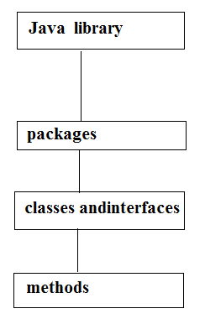
Note: if a programmer wants to use class, then that class should be imported into his program. If he wants to use a method, then that corresponding class or interface should be imported into his program.
In our program we are using two classes namely, System and String. These classes belong to a package called java.lang. So these two classes must be imported into our program
import java.lang.System
import java.lang.String
In import statement, the package name that we have written acts like a reference to the JVM to search for the classes there. JVM will not copy any code from the classes or packages. On the other hand, when a calss name or a method name is used, JVM goes to the java library, execute the code there, comes back, and substitutes the result in that place of the program. Thus , the java program size will not increased.
Q) What is difference b/w #include and import statement?
#include directive makes the compiler go to the C/C++ standard library and copy from the header files in to the program. As a result, the program size increases, thus wasting of memory and processor’s time.
import statement makes the JVM go to the java standard library, execute the code there, and substitute the result in to the program. Here no code copied and hence no waste of memory or processor’s time.
So import statement is an efficient mechanism than #include
Main Method:
Whether the class contains main() method or not, and whether it is properly declared or not, these checking's are not responsibilities of the compiler, at runtime JVM is responsible for this.
If JVM unable to find the required main() method then we will get runtime exception. saying NoSuchMethodError: main.
How many ways can we write a java program?
There are many ways to write a java program. The modifications that can be done in a java program are given below:
1) By changing sequence of the modifiers, method prototype is not changed.
static public void main(String args[])
2) subscript notation in java array can be used after type, before variable or after variable.
public static void main(String[] args)
public static void main(String []args)
public static void main(String args[])
3) You can provide var-args support to main method by passing 3 ellipses (dots)
public static void main(String... args)
5) Instead of args we can use any valid java identifier.
public static void main(String... veeru)
6) main() method can be declared with the following modifiers.
final, synchronized, strictfp.
class FristApp{
static final syncronized strictfp public void main(String... veeru){
System.out.println("hello java");
}
}
4) Having semicolon at the end of class in java is optional.
class FristApp{
static public void main(String... args){
System.out.println("hello java");
}
};
Valid java main method signature
- public static void main(String[] args)
- public static void main(String []args)
- public static void main(String args[])
- public static void main(String... args)
- static public void main(String[] args)
- public static final void main(String[] args)
- final public static void main(String[] args)
- final strictfp public static void main(String[] args)
Invalid java main method signature
- public void main(String[] args)
- static void main(String[] args)
- public void static main(String[] args)
- abstract public static void main(String[] args)
Internal Details of Hello Java Program:
At compile time
At compile time, java file is compiled by Java Compiler (It does not interact with OS) and converts the java code into bytecode.
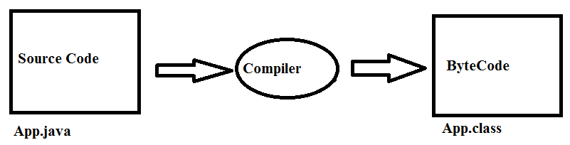At runtime:
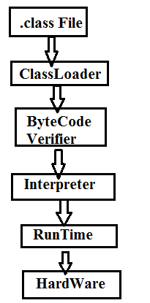
Classloader: is the subsystem of JVM that is used to load class files.
Bytecode Verifier: checks the code fragments for illegal code that can violate access right to objects.
Interpreter: read bytecode stream then execute the instructions.
Compile Time and Run Time-Diagram:
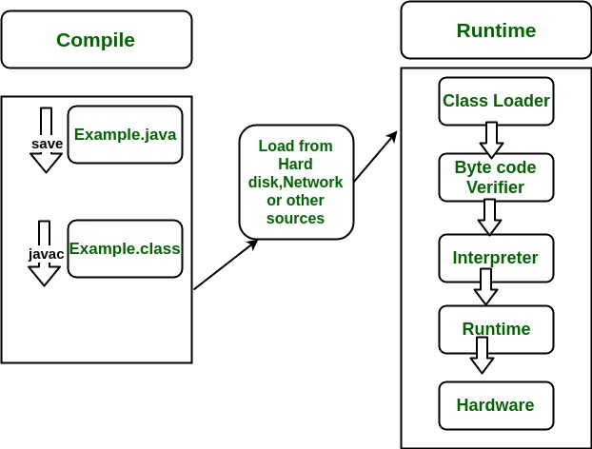
Q) Can you save a java source file by other name than the class name?
Yes, if the class is not public.
class FristApp{
static public void main(String... args){
System.out.println("hello java");
}
}
Save: Veeru.java
Compile: javac Veeru.java
Run: java Firstapp
Q) What is difference b/w print() and println()?
Both methods are used to display the results on the monitor.
Print() method displays the result and then retains the cursor in the same line, next to the end of the result.
Println() method displays the result and then throws the cursor to next line.
Q) What Happens if we are not writing String[] args in main method?
When main () method is written without String[] args
public static void main ()
The code will compile but JVM cannot run the code because it cannot recognize the main () method as the method from where it should start execution of the Java program. Remember JVM always looks for main () method with string type array as parameter.
Ex:
class Hello{
public static void main(){
System.out.println("Heelo world");
}
}
Compile time: no error
Runtime: Error

Java Fundamentals
Communicating with a computer involves speaking the language the computer understands, which immediately rules out English as the language of communication with computer. However, there is a close analogy between learning English language and learning java language. The classical method of learning English is to first learn the alphabets used in the language, then learn to combine these alphabets to form words, which in turn are combined to form sentences and sentences are combined to form paragraphs.
Learning Java is similar and easier. Instead of straight-away learning how to write programs, we must first know what alphabets, numbers and special symbols are used in Java, then how using them constants, variables and keywords are constructed, and finally how are these combined to form an instruction. A group of instructions would be combined later on to form a program.
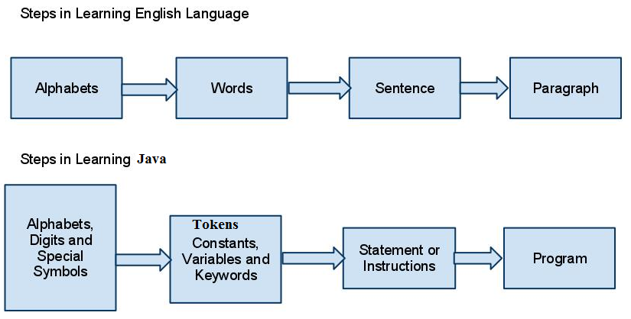

Java Tokens
A java Program is made up of Classes and Methods and in the Methods are the Container of the various Statements And a Statement is made up of Variables, Constants, operators etc.
Tokens are the various Java program elements which are identified by the compiler. A token is the smallest element of a program that is meaningful to the compiler. Tokens supported in Java include keywords, variables, constants, special characters, operations etc.
When you compile a program, the compiler scans the text in your source code and extracts individual tokens. While tokenizing the source file, the compiler recognizes and subsequently removes whitespaces (spaces, tabs, newline and form feeds) and the text enclosed within comments.
public class Tokens {
public static void main(String[] args) {
System.out.println(" Hello java");
}
}
The source code contains tokens such as public, class, Tokens, {, public, static, void, main, (, String, [], args, {, System, out, println, (, "Hello Java", }, }. The resulting tokens are compiled into Java bytecodes that is capable of being run from within an interpreted java environment. Token are useful for compiler to detect errors. When tokens are not arranged in a particular sequence, the compiler generates an error message.

Tokens are the smallest unit of Program There is Five Types of Tokens
1) Identifier
2) Reserve Word or Keywords
3) Literals
4) Operators
5) Separators
IDENTIFIER
In programming languages, identifiers are used for identification purpose.
A name in java program is called identifier. It may be class name, method name, variable name and label name.
- Test : class name.
- main : method name.
- String : predefined class name.
- args : variable name.
- x : variable name.

Rules to define java identifiers:
There are certain rules for defining a valid java identifiers. These rules must be followed; otherwise we get compile-time error. These rules are also valid for other languages like C,C++.
Rule 1: The only allowed characters in java identifiers are:
1) a to z
2) A to Z
3) 0 to 9
4) _ (underscore)
5) $
Rule 2: If we are using any other character we will get compile time error.
Example:
1) total_number-------valid
2) Total#------------------invalid
Ex:
class Identifer{
public static void main(String[] args){
int total_number;//valid
int Total#;//invalid -illegal character
}
}
Rule 3: identifiers are not allowed to starts with digit.
Example:
1) ABC123---------valid
2) 123ABC---------invalid
Ex:
class Identifer{
public static void main(String[] args){
int marks2;//valid
int 123marks;//invalid-compiletime error
}
}
Rule 4: java identifiers are case sensitive up course java language itself treated as case sensitive language.
Example:
class Identifer {
int number=10;
int Number=20;
int NUMBER=20; we can differentiate with case.
int NuMbEr=30;
}
Rule 5: There is no length limit for java identifiers but it is not recommended to take more than 15 lengths.
Rule 6: We can't use reserved words as identifiers.
Example:
int if=10; --------------invalid
class Identifer{
public static void main(String[] args){
int if=10; //invalid-compiletime error
}
}
Rule 7: All predefined java class names and interface names we use as identifiers.
Example 1:
class Test{
public static void main(String[] args){
int String=10;
System.out.println(String);
}
}
Output:
10
Example 2:
class Test{
public static void main(String[] args){
int Runnable=10;
System.out.println(Runnable);
}
}
Output:
10
Even though it is legal to use class names and interface names as identifiers but it is not a good programming practice.
Which of the following are valid java identifiers?

Reserved words
In java some identifiers are reserved to associate some functionality or meaning such type of reserved identifiers are called reserved words.
Diagram:

Reserved words for data types: (8)
1) byte
byte: Java byte keyword is used to declare a variable that can hold an 8-bit data values.
2) short
short: Java short keyword is used to declare a variable that can hold a 16-bit integer.
3) int
int: Java int keyword is used to declare a variable that can hold a 32-bit signed integer.
4) long
long: Java long keyword is used to declare a variable that can hold a 64-bit integer.

5) float
float: Java float keyword is used to declare a variable that can hold a 32-bit floating-point number.
6) double
double: Java double keyword is used to declare a variable that can hold a 64-bit floating-point numbers.
7) char
char: Java char keyword is used to declare a variable that can hold unsigned 16-bit Unicode characters
8) boolean
boolean: Java boolean keyword is used to declare a variable as a boolean type. It can hold True and False values only.
Reserved words for flow control:(11)
1) if
if: Java if keyword tests the condition. It executes the if block if condition is true.
2) else
else: Java else keyword is used to indicate the alternative branches in an if statement.
3) switch
switch: The Java switch keyword contains a switch statement that executes code based on test value. The switch statement tests the equality of a variable against multiple values.
4) case
case: Java case keyword is used to with the switch statements to mark blocks of text.

5) default
default: Java default keyword is used to specify the default block of code in a switch statement.
6) for
for: Java for keyword is used to start a for loop. It is used to execute a set of instructions/functions repeatedly when some conditions become true. If the number of iteration is fixed, it is recommended to use for loop.
7) do
do: Java do keyword is used in control statement to declare a loop. It can iterate a part of the program several times.
8) while
while: Java while keyword is used to start a while loop. This loop iterates a part of the program several times. If the number of iteration is not fixed, it is recommended to use while loop.
9) break
break: Java break keyword is used to break loop or switch statement. It breaks the current flow of the program at specified condition.
10) continue
continue: Java continue keyword is used to continue the loop. It continues the current flow of the program and skips the remaining code at the specified condition.
11) return
return: Java return keyword is used to return from a method when its execution is complete.

Keywords for modifiers:(11)
1) public
public: Java public keyword is an access modifier. It is used to indicate that an item is accessible anywhere. It has the widest scope among all other modifiers.
2) private
private: Java private keyword is an access modifier. It is used to indicate that a method or variable may be accessed only in the class in which it is declared.
3) protected
protected: Java protected keyword is an access modifier. It can be accessible within package and outside the package but through inheritance only. It can't be applied on the class.
4) static
static: Java static keyword is used to indicate that a variable or method is a class method. The static keyword in Java is used for memory management mainly.
5) final
final: Java final keyword is used to indicate that a variable holds a constant value. It is applied with a variable. It is used to restrict the user.
6) abstract
abstract: Java abstract keyword is used to declare abstract class. Abstract class can provide the implementation of interface. It can have abstract and non-abstract methods.
7) synchronized
synchronized: Java synchronized keyword is used to specify the critical sections or methods in multithreaded code.

8) native
native: Java native keyword is used to specify that a method is implemented in native code using JNI (Java Native Interface).
9) strictfp(1.2 version)
strictfp: Java strictfp is used to restrict the floating-point calculations to ensure portability.
10) transient
transient: Java transient keyword is used in serialization. If you define any data member as transient, it will not be serialized.
11) volatile
volatile: Java volatile keyword is used to indicate that a variable may change asynchronously.
Keywords for exception handling:(6)
1) try
try: Java try keyword is used to start a block of code that will be tested for exceptions. The try block must be followed by either catch or finally block.
2) catch
catch: Java catch keyword is used to catch the exceptions generated by try statements. It must be used after the try block only.
3) finally
finally: Java finally keyword indicates a block of code in a try-catch structure. This block is always executed whether exception is handled or not.

4) throw
throw: The Java throw keyword is used to explicitly throw an exception. The throw keyword is mainly used to throw custom exception. It is followed by an instance.
5) throws
throws: The Java throws keyword is used to declare an exception. Checked exception can be propagated with throws.
6) assert(1.4 version)
Class related keywords :(6)
1) class
class: Java class keyword is used to declare a class.
2) package
package: Java package keyword is used to declare a Java package that includes the classes.
3) import
import: Java import keyword makes classes and interfaces available and accessible to the current source code.
4) extends
extends: Java extends keyword is used to indicate that a class is derived from another class or interface.
5) implements
implements: Java implements keyword is used to implement an interface.
6) interface
interface: Java interface keyword is used to declare an interface. It can have only abstract methods.
Object related keywords:(4)
1) new
new: Java new keyword is used to create new objects.
2) instanceof
instanceof: Java instanceof keyword is used to test whether the object is an instance of the specified class or implements an interface.
3) super
super: Java super keyword is a reference variable that is used to refer parent class object. It can be used to invoke immediate parent class method.
4) this
this: Java this keyword can be used to refer the current object in a method or constructor.
Void return type keyword:
If a method won't return anything compulsory that method should be declared with the void return type in java but it is optional in C++.
1) void
void: Java void keyword is used to specify that a method does not have a return value.
Unused keywords:
goto: Create several problems in old languages and hence it is banned in java.
Const: Use final instead of this.
By mistake if we are using these keywords in our program we will get compile time error.

Reserved literals
1) true values for boolean data type.
2) false
3) null----------------- default value for object reference.
null: Java null keyword is used to indicate that a reference does not refer to anything. It removes the garbage value.
Enum:
This keyword introduced in 1.5v to define a group of named constants
enum: Java enum keyword is used to define a fixed set of constants. Enum constructors are always private or default.
Example:
enum Beer{
KF, RC, KO, FO;
}
Conclusions :
1. All reserved words in java contain only lowercase alphabet symbols.
2. New keywords in java are:
3. strictfp-----------1.2v
4. assert-------------1.4v
5. enum--------------1.5v
Note: In java we have only new keyword but not delete because destruction of useless objects is the responsibility of Garbage Collection.
Confusion keywords:
instanceof but not instanceOf
strictfp but not strictFp
const but not Constant
syncronized but not syncronize
extends but not extend
implements but not implement
import but not imports
int but not Int
Which of the following list contains only java reserved words ?
1. final, finally, finalize (invalid) //here finalize is a method in Object class.
2. throw, throws, thrown(invalid) //thrown is not available in java
3. break, continue, return, exit(invalid) //exit is not reserved keyword
4. goto, constant(invalid) //here constant is not reserved keyword
5. byte, short, Integer, long(invalid) //here Integer is a wrapper class
6. extends, implements, imports(invalid) //imports keyword is not available in java
7. finalize, synchronized(invalid) //finalize is a method in Object class
8. instanceof, sizeOf(invalid) //sizeOf is not reserved keyword
9. new, delete(invalid) //delete is not a keyword
10. None of the above (valid)

Which of the following are valid java keywords?
1. public(valid)
2. static(valid)
3. void(valid)
4. main(invalid)
5. String(invalid)
6. args(invalid)
DATA TYPES
Every variable has a type, every expression has a type and all types are strictly define more over every assignment should be checked by the compiler by the type compatibility hence java language is considered as strongly typed programming language.
Ex:
public class Demo {
public static void main(String[] args) {
//a=10;//invalid
int a=10;//valid
//int a=10.9;//invalid
}
}
Note: Java is a statically-typed programming language. It means, all variables must be declared before its use. That is why we need to declare variable's type and name.

Need of Data Types
- Data Types are used to store data temporarily in computer through a program
- The data type will specify the type of data that will be stored into a memory location.
- Every variable in Java has a data type which tells the compiler what type of variable it as and what type of data it is going to store.
- Data type specifies the size and type of values.
- Information is stored in computer memory with different data types.
- Whenever a variable is declared, it becomes necessary to define a data type that what will be the type of data that variable can hold.
Data type is a special keyword used to allocate sufficient memory space for the data, in other words Data type is used for representing the data in main memory (RAM) of the computer. Data types represent the different values to be stored in the variable. Every data type has a range of values. The compiler allocates memory space for each variable or constant according to its data type. Java provides eight primitive data types for numeric values, characters, and Boolean values. This section introduces numeric data types.
Java is pure object oriented programming or not?
Java is not considered as pure object oriented programming language because several oops features (like multiple inheritance, operator overloading) are not supported by java moreover we are depending on primitive data types which are non objects.

Different Java Data Types:
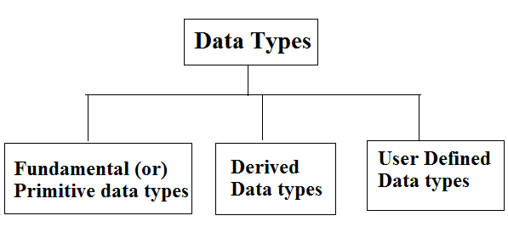
Primitive Data Types
There are eight primitive datatypes supported by Java. Primitive datatypes are predefined by the language and named by a keyword.
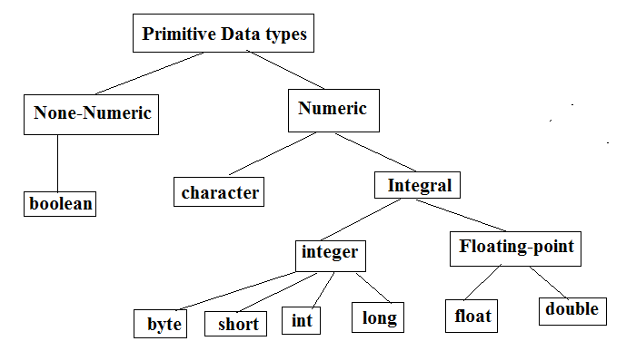
Note: Except Boolean and char all remaining data types are considered as signed data types because we can represent both "+ve" and"-ve" numbers.
Integral data types :
Byte:
Size: 1byte (8bits)
Max-value: +127
Min-value:-128
Range:-128 to 127[-2⁷ to 2⁷-1]
- The most significant bit acts as sign bit. "0" means "+ve" number and "1" means "–ve" number.
- "+ve" numbers will be represented directly in the memory whereas "–ve" numbers will be represented in 2's complement form.
- Default value is 0
Ex:
public class ByteEx {
public static void main(String[] args) {
byte b=10;
/*byte b2=130;
Compiletime error:possible loss of precision
found : int
required : byte*/
//byte b=10.5;//C.E:possible loss of precision
//byte b=true;//C.E:incompatible types
/*byte b="veeru";//C.E:incompatible types
found : java.lang.String
required : byte*/
}
}
Note: byte data type is best suitable if we are handling data in terms of streams either fromthe file or from the network.
Ex:
public class ByteEx2 {
public static void main(String[] args) {
byte a = 126;
// byte is 8 bit value
System.out.println(a + "\n");
a++;
System.out.println(a + "\n");
// It overflows here because
// byte can hold values from -128 to 127
a++;
System.out.println(a + "\n");
// Looping back within the range
a++;
System.out.println(a + "\n");
}
}
Short:
The most rarely used data type in java is short.
Size: 2 bytes
Range: -32768 to 32767(-215 to 215-1)
- Short data type is a 16-bit signed two's complement integer
- Minimum value is -32,768 (-2^15)
- Maximum value is 32,767 (inclusive) (2^15 -1)
- Short data type can also be used to save memory as byte data type. A short is 2 times smaller than an integer
- Default value is 0.
- Example: short s = 10000, short r = -20000

Example:
short s=130;
short s=32768;//C.E:possible loss of precision
short s=true;//C.E:incompatible types
Ex:
public class ShortEx {
public static void main(String[] args) {
short s1=10;
System.out.println(s1);
short s2=32767;
System.out.println(s2);
//short s3=32768;//Type mismatch: cannot convert from int to short
//System.out.println(s3);
}
}
Note:
Short data type is best suitable for 16 bit processors like 8086 but these processors are completely outdated and hence the corresponding short data type is also out data type.

int
- Int data type is a 32-bit signed two's complement integer.
- Size: 4 bytes
- Minimum value is - 2,147,483,648 (-2^31)
- Maximum value is 2,147,483,647(inclusive) (2^31 -1)
- Integer is generally used as the default data type for integral values unless there is a concern about memory.
- The default value is 0
- Example: int a = 100000, int b = -200000
Ex:
public class IntEx {
public static void main(String[] args) {
int i1=130;
System.out.println(i1);
//int i2=10.5;
//System.out.println(i2);//C.E:possible loss of precision
//int i3=true;//C.E:incompatible types
//System.out.println(i3);
//int i4="veeru";//C.E:incompatible types
//System.out.println(i4);
}
}
Long:
Note:
Whenever int is not enough to hold big values then we should go for long data type.
- Long data type is a 64-bit signed two's complement integer
- Minimum value is -9,223,372,036,854,775,808(-2^63)
- Maximum value is 9,223,372,036,854,775,807 (inclusive)(2^63 -1)
- This type is used when a wider range than int is needed
- Default value is 0L
- Example: long a = 100000L, long b = -200000L
Note: All the above data types (byte, short, int and long) can be used to represent whole numbers. If we want to represent real numbers then we should go for floating point data types.
Float:
- Float data type is a single-precision 32-bit IEEE 754 floating point
- Float is mainly used to save memory in large arrays of floating point numbers
- Default value is 0.0f
- Float data type is never used for precise values such as currency
- Example: float f1 = 234.5f
Double:
- double data type is a double-precision 64-bit IEEE 754 floating point
- This data type is generally used as the default data type for decimal values, generally the default choice
- Double data type should never be used for precise values such as currency
- Default value is 0.0d
- Example: double d1 = 123.4
Difference between float and double:
Float | double
If we want to 5 to 6 decimal places of accuracy then we should go for float. | If we want to 14 to 15 decimal places of accuracy then we should go for double.
Size:4 bytes. | Size:8 bytes.
float follows single precision. | double follows double precision.

boolean
- boolean data type represents one bit of information
- There are only two possible values: true and false
- This data type is used for simple flags that track true/false conditions
- Default value is false
- Example: boolean one = true
Note:
Size: Not applicable (virtual machine dependent)
Range: Not applicable but allowed values are true or false.
Why Boolean data types take zero byte of memory?
Boolean data type takes zero bytes of main memory space because Boolean data type of java implemented by Sun Micro System with a concept of flip - flop. A flip - flop is a general purpose register which stores one bit of information (one true and zero false).
Note: In C, C++ (Turbo) Boolean data type is not available for representing true false values but a true value can be treated as non-zero value and false values can be represented by zero
Ex:
public class BooleanEx {
public static void main(String[] args) {
boolean b=true;
boolean b1=True;//C.E:cannot find symbol
boolean b2="True";//C.E:incompatible types
boolean b3=0;//C.E:incompatible types
}
}
Ex:
public class BooleanEx2 {
public static void main(String[] args) {
int x=10;
if(x){
System.out.println("Hello World!");
}
else{
System.out.println("bye World!");
}
}
}
Output:
BooleanExample2.java:6: error: incompatible types
if(x)
required: boolean
found: int
Ex:
public class BooleanEx {
public static void main(String[] args) {
while(1){
System.out.println("hello");
}
}
}
Output:
BooleanExample3.java:5: error: incompatible types
while(1)
required: boolean
found: int
Char:
- char data type is a single 16-bit Unicode character
- Minimum value is '\u0000' (or 0)
- Maximum value is '\uffff' (or 65,535 inclusive)
- Char data type is used to store any character
- Example: char letterA = 'A'
Note:
In old languages like C & C++ are ASCII code based the no.Of ASCII code characters are < 256 to represent these 256 characters 8 - bits enough hence char size in old languages 1 byte.
In java we are allowed to use any worldwide alphabets character and java is Unicode based and no.Of unicode characters are > 256 and <= 65536 to represent all these characters one byte is not enough compulsory we should go for 2 bytes.
Size: 2 bytes
Range: 0 to 65535
Ex:
public class BooleanEx {
public static void main(String[] args) {
char ch1=97;
System.out.println(ch1);
char ch2=65536;//C.E:possible loss of precision
//System.out.println(ch2);
}
}
Output: Compile time error
Ex:
public class CharEx {
public static void main(String[] args) {
char character1, character2;
character1 = 82; // code for X
character2 = 'S';
System.out.print("character1 and character2: ");
System.out.println(character1 + " " + character2);//R S
}
}
Unicode System
Unicode is a universal international standard character encoding that is capable of representing most of the world's written languages.
Why java uses Unicode System?
Before Unicode, there were many language standards:
- ASCII (American Standard Code for Information Interchange) for the United States.
- ISO 8859-1 for Western European Language.
- KOI-8 for Russian.
- GB18030 and BIG-5 for chinese, and so on.
Problem
This caused two problems:
- A particular code value corresponds to different letters in the various language standards.
- The encodings for languages with large character sets have variable length. Some common characters are encoded as single bytes, other require two or more byte.
Solution
To solve these problems, a new language standard was developed i.e. Unicode System.
In unicode, character holds 2 byte, so java also uses 2 byte for characters.
lowest value:\u0000
highest value:\uFFFF
Why Java take 2 byte of memory for store character ?
Java support more than 18 international languages so java take 2 byte for characters, because for 18 international language 1 byte of memory is not sufficient for storing all characters and symbols present in 18 languages. Java supports Unicode but c support ascii code. In ascii code only English language are present, so for storing all English latter and symbols 1 byte is sufficient. Unicode character set is one which contains all the characters which are available in 18 international languages and it contains 65536 characters
Derived data types:
Derived data types are those whose variables allow us to store multiple values of same type. But they never allows to store multiple values of different types. These are the data type whose variable can hold more than one value of similar type. In general derived data type can be achieve using array.
Categories of Derived Data Types:
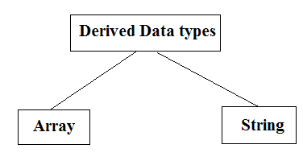
Example
int a[] = {10,20,30}; // valid
int b[] = {100, 'A', "ABC"}; // invalid
Note:
There are majorly two types of languages.
- Statically typed language
- Dynamically typed languages
Statically typed language where each variable and expression type is already known at compile time. Once a variable is declared to be of a certain data type, it cannot hold values of other data types.
Example: C, C++, Java.
Dynamically typed languages: These languages can receive different data types over the time. Ruby, Python
Java is statically typed and also a strongly typed language because in Java, each type of data (such as integer, character, hexadecimal, packed decimal, and so forth) is predefined as part of the programming language and all constants or variables defined for a given program must be described with one of the data types.
Limitations of primitive data types:
- Using primitive data types we cannot store multiple values in continuous memory locations
- Due to this limitation we have to face 2 problems.
Case-1:
- For instance if we want to store multiple values, for example 1 to 100 , we must create 100 variables. All those variables created across JVM at different locations as shown below.
- Hence it takes more time to retrieve values.
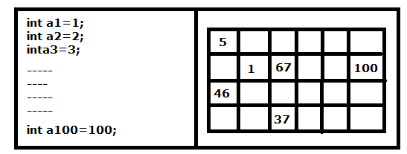
Case-2:
- Also using variables we cannot pass all values to the remote computer with single network call, which increases burden on network and also increase lines of code in program.

Referenced data types:
- To solve above two problems, values must be stored in continuous memory locations with single variable name .
- This can be possible using referenced types.
- Referenced types are given to store values in continuous memory locations with single variable name to retrieve data in quick time and to pass all values with single network call.
- Array
- Class
- Interface
Default value of any reference variable is null.
A reference variable can be used to refer any object of the declared type or any compatible type.
Example
Gender male = new Gender("yes");
Note: In java both derived and user defined data type combined name as reference data type.
In C language, user defined data types can be developed by using struct, union, enum etc. In java programming user defined datatype can be developed by using the features of classes and interfaces.

Object and Class in Java
Class in Java:
A class is a group of objects which have common properties. It is a template or blueprint from which objects are created. It is a logical entity. It can't be physical.
A class in Java can contain:
- fields
- methods
- constructors
- blocks
- nested class and interface
Syntax to declare a class:
class <class_name>{
field;
method;
}
Method in Java:
In java, a method is like function i.e. used to expose behavior of an object.
A Java method is a collection of statements that are grouped together to perform an operation. When you call the System.out.println() method, for example, the system actually executes several statements in order to display a message on the console.

Object in Java:
Object is the physical as well as logical entity whereas class is the logical entity only.
Object is the physical as well as logical entity whereas class is the logical entity only.
An entity that has state and behavior is known as an object e.g. chair, bike, marker, pen, table, car etc. It can be physical or logical (tangible and intangible). The example of intangible object is banking system.
An object has three characteristics:
- state: represents data (value) of an object.
- behavior: represents the behavior (functionality) of an object such as deposit, withdraw etc.
- identity: Object identity is typically implemented via a unique ID. The value of the ID is not visible to the external user. But, it is used internally by the JVM to identify each object uniquely.
Example:
Pen is an object. Its name is Reynolds, color is white etc. known as its state. It is used to write, so writing is its behavior.
Object is an instance of a class. Class is a template or blueprint from which objects are created. So object is the instance(result) of a class.
Object Definitions:
- Object is a real world entity.
- Object is a run time entity.
- Object is an entity which has state and behavior.
- Object is an instance of a class.

new keyword in Java:
The new keyword is used to allocate memory at run time. All objects get memory in Heap memory area.
Object and Class Example: main within class:
We have created a Student class that has two data members’ id and name. We are creating the object of the Student class by new keyword and printing the objects value.
Here, we are creating main() method inside the class.
File: Student.java
class Student{
//field or data member or instance variable
int id;
String name;
public static void main(String args[]){
//creating an object of Student
Student s1=new Student();
//accessing member through reference variable
System.out.println(s1.id);
System.out.println(s1.name);
}
}
Output:
0
null
Object and Class Example: main outside class:
In real time development, we create classes and use it from another class. It is a better approach than previous one. Let's see a simple example, where we are having main() method in another class.
We can have multiple classes in different java files or single java file. If you define multiple classes in a single java source file, it is a good idea to save the file name with the class name which has main() method.
File: TestStudent1.java
class Student{
int id;
String name;
}
class TestStudent1{
public static void main(String args[]){
Student s1=new Student();
System.out.println(s1.id);
System.out.println(s1.name);
}
}
Output:
0
null
3 Ways to initialize object:
There are 3 ways to initialize object in java.
- By reference variable
- By method
- By constructor
1) Object and Class Example: Initialization through reference
Initializing object simply means storing data into object. Let's see a simple example where we are going to initialize object through reference variable.
File: TestStudent2.java
class Student{
int id;
String name;
}
class TestStudent2{
public static void main(String args[]){
Student s1=new Student();
s1.id=101;
s1.name="Veerendra";
System.out.println(s1.id+" "+s1.name);//printing members with a white space
}
}
Output:
101 Veerendra
We can also create multiple objects and store information in it through reference variable.
File: TestStudent3.java
class Student{
int id;
String name;
}
class TestStudent3{
public static void main(String args[]){
//Creating objects
Student s1=new Student();
Student s2=new Student();
//Initializing objects
s1.id=101;
s1.name="Veerendra";
s2.id=102;
s2.name="Pawankalyan";
//Printing data
System.out.println(s1.id+" "+s1.name);
System.out.println(s2.id+" "+s2.name);
}
}
Output:
101 veerendra
102 Pawankalyan
2) Object and Class Example: Initialization through method
In this example, we are creating the two objects of Student class and initializing the value to these objects by invoking the insertRecord method. Here, we are displaying the state (data) of the objects by invoking the displayInformation() method.
File: TestStudent4.java
class Student{
int rollno;
String name;
//Method
void insertRecord(int r, String n){
rollno=r;
name=n;
}
void displayInformation(){
System.out.println(rollno+" "+name);
}
}
class TestStudent4{
public static void main(String args[]){
Student s1=new Student();
Student s2=new Student();
s1.insertRecord(333,"kajal");
s2.insertRecord(222,"veerendra");
s1.displayInformation();
s2.displayInformation();
}
}
Output:
222 veerendra
333 kajal
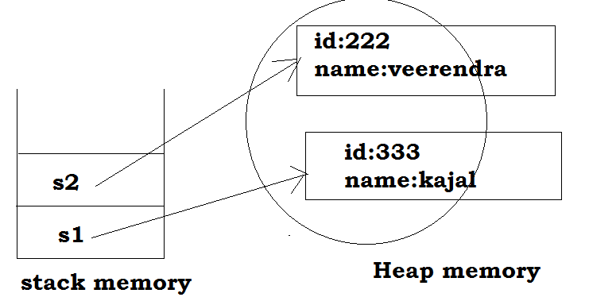

Method in Java:
In java, a method is like function i.e. used to expose behavior of an object.
A Java method is a collection of statements that are grouped together to perform an operation. When you call the System.out.println() method, for example, the system actually executes several statements in order to display a message on the console.
Types of Java methods:
Depending on whether a method is defined by the user, or available in standard library, there are two types of methods:
- Standard Library Methods/ Pre-defined Methods
- User-defined Methods
Standard Library Methods
The standard library methods are built-in methods in Java that are readily available for use. These standard libraries come along with the Java Class Library (JCL) in a Java archive (*.jar) file with JVM and JRE.
For example,
- print() is a method of java.io.PrintSteam. The print("...") prints the string inside quotation marks.
- sqrt() is a method of Math class. It returns square root of a number.
Ex:
public class Numbers{
public static void main(String[] args) {
System.out.print("Square root of 4 is: " + Math.sqrt(4));
}
}
Output:
Square root of 4 is: 2.0
User-defined Method
You can also define methods inside a class as per your wish. Such methods are called user-defined methods.
How to create a user-defined method?
Syntax
public static int methodName(int a, int b) {
// body
}
Here,
- public static − modifier
- int − return type—it not mandatory (Optional)
- methodName − name of the method
- a, b − formal parameters
- int a, int b − list of parameters--- it’s also not mandatory (Optional)

One more level:
Syntax
modifier returnType nameOfMethod (Parameter List)
{
// method body
}
The syntax shown above includes −
- modifier − It defines the access type of the method and it is optional to use.
- returnType − Method may return a value.
- nameOfMethod − This is the method name. The method signature consists of the method name and the parameter list.
- Parameter List − The list of parameters, it is the type, order, and number of parameters of a method. These are optional, method may contain zero parameters.
- method body − The method body defines what the method does with the statements.
One more level:
modifier static returnType nameOfMethod (Parameter List) {
// method body
}
Here,
- modifier - defines access type whether the method is public, private and so on.
- static - If you use static keyword in a method then it becomes a static method. Static methods can be called without creating an instance of a class.
For example, the sqrt() method of standard Math class is static. Hence, we can directly call Math.sqrt() without creating an instance of Math class.
- returnType - A method can return a value.
It can return native data types (int, float, double etc.), native objects (String, Map, List etc.), or any other built-in and user defined objects.
If the method does not return a value, its return type is void.
- nameOfMethod - The name of the method is an identifier.
You can give any name to a method. However, it is more conventional to name it after the tasks it performs. For example, calculateInterest, calculateArea, and so on.
- Parameters (arguments) - Parameters are the values passed to a method. You can pass any number of arguments to a method.
- Method body - It defines what the method actually does, how the parameters are manipulated with programming statements and what values are returned. The codes inside curly braces { } is the body of the method.
Ex:
public static void myMethod() {
System.out.println(“My Function called”);
}

How to call a Java Method?
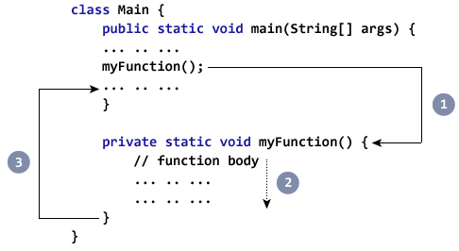
- While Java is executing the program code, it encounters myMethod(); in the code.
- The execution then branches to the myFunction() method, and executes code inside the body of the method.
- After the codes execution inside the method body is completed, the program returns to the original state and executes the next statement
Example: Complete Program of Java Method
class Main {
public static void main(String[] args) {
System.out.println("About to encounter a method.");
// method call
myMethod();
System.out.println("Method was executed successfully!");
}

// method definition
private static void myMethod(){
System.out.println("Printing from inside myMethod()!");
}
}
Output:
About to encounter a method.
Printing from inside myMethod().
Method was executed successfully!
Note:
The method myMethod() in the above program doesn't accept any arguments. Also, the method doesn't return any value (return type is void).
Note that, we called the method without creating object of the class. It was possible because myMethod() is static.
Ex:
In this example, our method is non-static and is inside another class
class Main {
public static void main(String[] args) {
Output obj = new Output();
System.out.println("About to encounter a method.");
// calling myMethod() of Output class
obj.myMethod();
System.out.println("Method was executed successfully!");
}
}
class Output {
// public: this method can be called from outside the class
public void myMethod() {
System.out.println("Printing from inside myMethod().");
}
}
Java Methods with Arguments and Return Value:
A Java method can have zero or more parameters. And, they may return a value.
Example: Return Value from Method
class SquareMain {
public static void main(String[] args) {
int result;
result = square();
System.out.println("Squared value of 10 is: " + result);
}
public static int square() {
// return statement
return 10 * 10;
}
}
Output:
Squared value of 10 is: 100
Note: the return type of square() method is int. Meaning, the method returns an integer value.
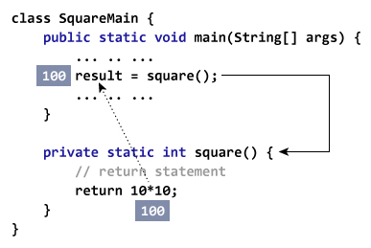
Example: Method Accepting Arguments and Returning Value
public class SquareMain {
public static void main(String[] args) {
int result, n;
n = 3
result = square(n);
System.out.println("Square of 3 is: " + result);
n = 4
result = square(n);
System.out.println("Square of 4 is: " + result);
}
static int square(int i) {
return i * i;
}
}
Output:
Squared value of 3 is: 9
Squared value of 4 is: 16
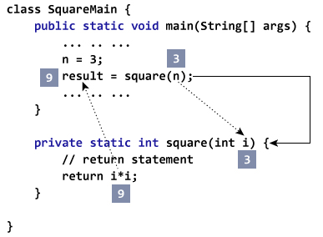
You can pass more than one argument to the Java method by using commas. For example,
public class ArithematicMain {
public static int getIntegerSum (int i, int j) {
return i + j;
}
public static int multiplyInteger (int x, int y) {
return x * y;
}
public static void main(String[] args) {
System.out.println("10 + 20 = " + getIntegerSum(10, 20));
System.out.println("20 x 40 = " + multiplyInteger(20, 40));
}
}
Output:
10 + 20 = 30
20 x 40 = 800
Example: Get Squared Value Of Numbers from 1 to 5
public class JMethods {
// method defined
private static int getSquare(int x){
return x * x;
}
public static void main(String[] args) {
for (int i = 1; i <= 5; i++) {
// method call
result = getSquare(i)
System.out.println("Square of " + i + " is : " + result); }
}
}
Output :
Square of 1 is : 1
Square of 2 is : 4
Square of 3 is : 9
Square of 4 is : 16
Square of 5 is : 25
Ex: swapping two numbers
public class swappingExample {
public static void main(String[] args) {
int a = 30;
int b = 45;
System.out.println("Before swapping, a = " + a + " and b = " + b);
// Invoke the swap method
swapFunction(a, b);
System.out.println("\n**Now, Before and After swapping values will be same here**:");
System.out.println("After swapping, a = " + a + " and b is " + b);
}
public static void swapFunction(int a, int b) {
System.out.println("Before swapping(Inside), a = " + a + " b = " + b);

// Swap n1 with n2
int c = a;
a = b;
b = c;
System.out.println("After swapping(Inside), a = " + a + " b = " + b);
}
}
This will produce the following result −
Output
Before swapping, a = 30 and b = 45
Before swapping(Inside), a = 30 b = 45
After swapping(Inside), a = 45 b = 30
**Now, Before and After swapping values will be same here**:
After swapping, a = 30 and b is 45
Advantage of Method
- Code Reusability
- Code Optimization
3) Object and Class Example: Initialization through constructor
In Java, constructor is a block of codes similar to method. It is called when an instance of object is created and memory is allocated for the object.
It is a special type of method which is used to initialize the object.
Note: It is called constructor because it constructs the values at the time of object creation. It is not necessary to write a constructor for a class. It is because java compiler creates a default constructor if your class doesn't have any.
Example of default constructor that displays the default values
class Student3{
int id;
String name;
void display(){System.out.println(id+" "+name);}
public static void main(String args[]){
Student3 s1=new Student3();
Student3 s2=new Student3();
s1.display();
s2.display();
}
}
Output:
0 null
0 null
Explanation:
In the above class,you are not creating any constructor so compiler provides you a default constructor.Here 0 and null values are provided by default constructor.
Java parameterized constructor:
A constructor which has a specific number of parameters is called parameterized constructor.
Why use parameterized constructor?
Parameterized constructor is used to provide different values to the distinct objects.
Example of parameterized constructor
In this example, we have created the constructor of Student class that have two parameters. We can have any number of parameters in the constructor.
class Student4{
int id;
String name;
Student4(int i,String n){
id = i;
name = n;
}
void display(){System.out.println(id+" "+name);
}
public static void main(String args[]){
Student4 s1 = new Student4(111,"Karan");
Student4 s2 = new Student4(222,"Aryan");
s1.display();
s2.display();
}
}
Output:
111 Karan
222 Aryan

